26th September 2018

**YOKOHAMA’s New Technology for Improved Ice Performance**

YOKOHAMA in a joint research project with the Tribology Laboratory headed by Associate Professor Iwai of the College of Science and Engineering at Kanazawa University, has developed an evaluation technology that visualizes rubber’s frictional state of contact on an icy surface (image of a tyre in motion). The new evaluation technology will enable the discovery of new compounding agents with excellent water absorbency and facilitate more precise development of tread patterns that deliver higher drainage performance. The technology is expected to lead to the development of winter tyres with dramatically improved ice performance.  
  
When running on ice, the tyre’s inability to make firm contact with the road surface due to the watery film generated by the icy surface reduces the tyre’s grip. Studless snow tyres use water absorbing agents and tread patterns with high drainage performance to counter the watery film. However, when observing tyres’ contact with the road, it has been difficult to distinguish the area where water is between the road surface and the rubber from the area where the rubber is in direct contact with the road surface (real contact area). As a result, it has been difficult to accurately grasp the degree of real contact. The joint research project between YOKOHAMA and Kanazawa University developed a specialized testing machine equipped with a high-speed camera that enables visualization of the tyres’ contact with the ground and succeeds in identifying the real contact area. Furthermore, by establishing an analytical technique for digitizing contact images, YOKOHAMA succeeded in numerically evaluating the water absorbency and drainage of tyre rubber.   
  
The specialized testing machine is able to directly observe frictional behaviour between a rubber sample and ice or a smooth transparent disk used to replicate ice at speeds of up to 50km/hr. Its high-speed camera can take one million micro-level images per second of the tyre rubber’s contact area with the road surface. It also can simultaneously measure the frictional force during the test. Images taken with this testing machine are dark only in the real contact area. Rubber that includes a water-absorbing agent shows darkness over a wider area than rubber that does not include the water-absorbing agent. Furthermore, as a result of digitizing the image with the newly developed analytical technique to associate the contact area with the frictional force, it was revealed that the calculated numerical value has a high correlation with the frictional force of the rubber.  
  
The consumer tire strategy in YOKOHAMA’s three-year medium-term management plan, the Grand Design 2020 (GD2020), which was launched in 2018, includes a winter tyre strategy that aims to assert performance leadership in winter tyres supplied in the Japanese, European, and Russian markets. YOKOHAMA is using the new technology widely in its development of a broad range of winter tyres, from studless snow tyres for Japan to winter tyres for the European market and all-season tyres. Using this technology, YOKOHAMA will accelerate product development as it aims to build leadership in the performance of winter tyres.

###### Image of contact area taken by specialized testing machine (Rubber with water-absorbing agent and rubber w/o water-absorbing agent)

While the rubber not including a water-absorbing agent has few black spots (real contact area), indicating little direct contact between tyre and road surface, the rubber including a water-absorbing agent has many more black spots, which clearly shows the expansion of real contact achieved by the use of the water-absorbing agent.

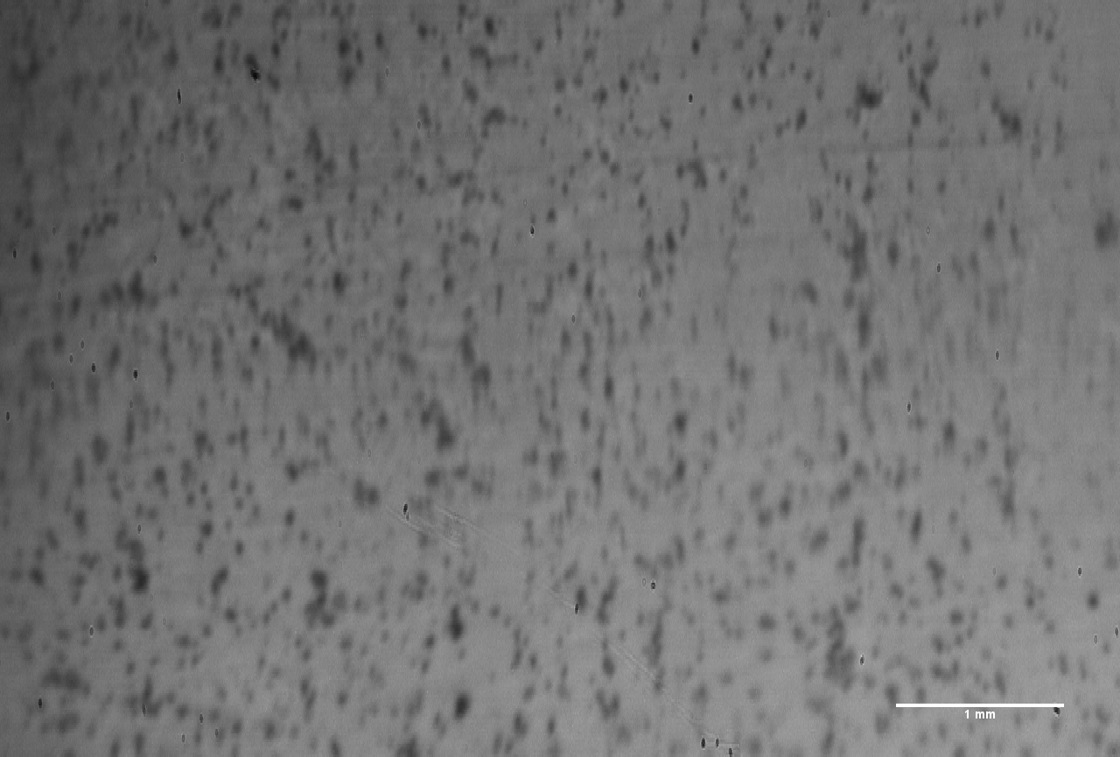

*Image of contact area taken by specialized testing machine (Rubber with water-absorbing agent)*

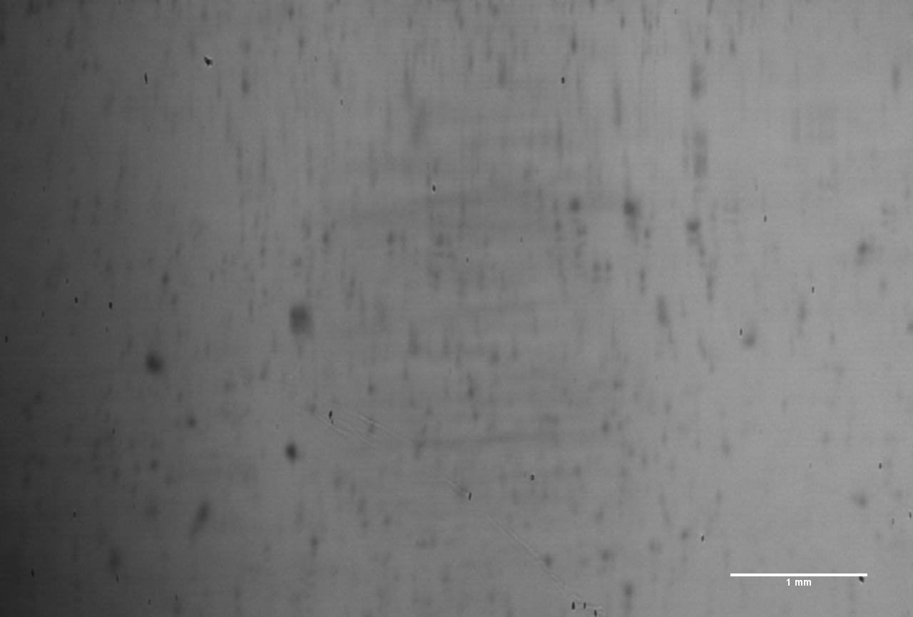

*Image of contact area taken by specialized testing machine (Rubber w/o water-absorbing agent)*